Memorandum

To: Higher Degree Research Committee
From: Prof. Michelle Leishman, Department of Biological Sciences
Re: PhD examination – JAMES LAWSON
Date: 14 December 2015

Tracy Rushmer (FSE AD-HDR) has requested some additional information concerning the examiners’ reports on James Lawson’s thesis. Specifically she has asked if I can respond to Naiman's report on points 2 - 7 in his "Specific Comments on Research". In addition she requested comment on the sampling techniques employed. My comments are provided below.

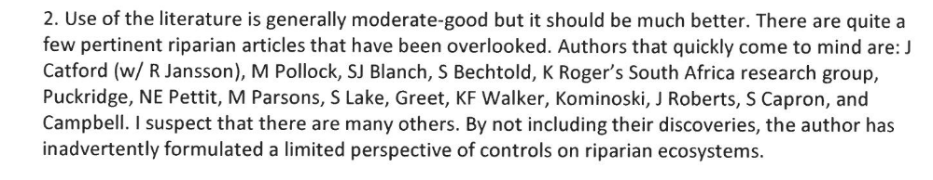
James has cited Catford et al. extensively throughout the thesis, as well as other authors mentioned by Naiman (Greet, Kominoski, Capon). The literature describing qualitative functional responses of riparian vegetation to various environmental gradients (including publications by the authors listed by the reviewer) is very extensive, however James’ research was mostly focused on quantitative, functional trait-based approaches and thus not all authors mentioned by Naiman were appropriate to be cited. However some additional citations could be added to the Introductory chapter if necessary.

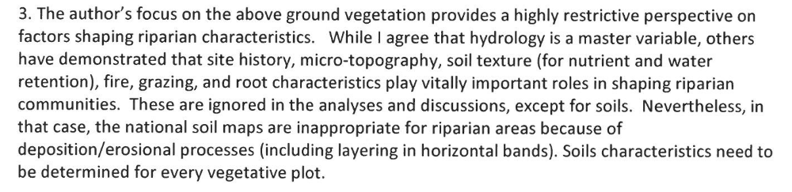
We are aware that there are many more factors that influence ecological communities than a single set of processes. However I don’t believe James suggested that local flow regime is the only important factor influencing the ecology of riparian vegetation communities. In Chapters 2-4 he modelled relationships between community descriptors and gradients of statistical metrics of flow regime. He found strong links and the results fit well within the prevailing paradigm that flow regime is an important, even dominant control on riparian ecology. He couldn’t measure or account for every source of variation and in peer review (Ch’s 2&3) was cautioned not to discuss variables which had not been quantified. Nevertheless James could add a few paragraphs to more clearly define the scope of his investigations and their place within 21st century riparian ecology.
With respect to the soil data, we acknowledge that the resolution of national soil map data is insufficient to fully characterize soil characteristics. James did sample soils in the field but unfortunately ran into problems with soil storage, rendering the samples unusable. The national soil maps were the next best option and their scale is acknowledged in the thesis.

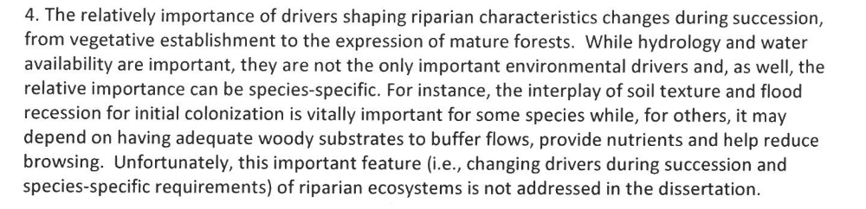

We agree with Naiman that the interplay between succession and biophysical processes is a fascinating and fundamental aspect of riparian ecology. The benefit of functional trait-based approaches, as employed by James, is to allow assertions to be made about the function of plant communities in which species-specific knowledge is lacking. The sort of work Naiman is suggesting would require fine scale analysis of species case studies, as opposed to the macroecological environmental gradient analyses described here. This is quite a different approach, but both approaches are appropriate in different circumstances.

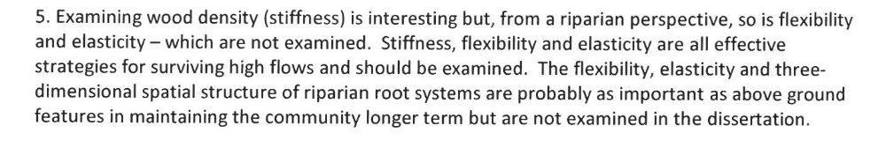

Again we agree with Naiman. Stem flexibility, elasticity and root architecture are of fundamental importance in mediating plant responses to fluvial disturbance. James chose to examine wood density because wood density is known to be a key plant functional trait. A wealth of studies in the functional ecology literature describe the role of wood density in plant ecological strategy, economic spectra associated with wood density, and variation in wood density along numerous environmental and ecological gradients. Using wood density in Chapter 2 allowed James to situate his work within a broader context in plant functional ecology. Studies describing below-ground functional traits of riparian vegetation are sorely needed to extend riparian functional ecology, but to date have been hampered by the difficulty, cost and destructiveness of working on tree roots.


This was also requested by Examiner 1 (Stromberg). James has field notes on each site described in Ch2&3 including systematic photography and cross-section sketches. However detailed histories are unfortunately difficult to determine for a number of sites. He does not have access to this data for Ch4 as the data were collected for a project he was not involved with. If required, James could provide detailed site data for the 15 sites of chapters 2 & 3 which would comprise a fairly large appendix. However, as both these chapters are now published, I do not think that providing the site information in the appendix of his thesis is really necessary.

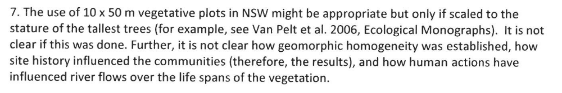

The described scaling was not performed, however canopy height was fairly similar across sites and that plot size was judged suitable. Geomorphic homogeneity was established by visual inspection and qualitative judgement. Site history is always an issue in ecological studies, and is not easily determined. James attempted to minimize the influence of site history and human alteration of river flows by choosing sites in minimally altered catchments along unregulated rivers. Given the requirement that sites be adjacent to flow gauging stations, unfortunately several sites had undergone some form of human alteration. However this was mentioned in the thesis.

regards


Professor Michelle Leishman (Principal supervisor)

